
Medicinal Herbs Identification System
Using Deep Learning for Leaf Image Classification
Project Report
Submitted by:
Sumanth G
Roll Number / Employee ID: To be filled
Department: Tech Team
Institution/Organization: DataLegos

Submitted to:
Name: To be filled
Designation: To be filled
Department: To be filled
Date of Submission: 5th June 2025
Location: Nellore

System Design Document: High-Level Design (HLD)
Project Title: Medicinal Herbs Identification Web Application
Version: 1.0
Author: Sumanth G
Date: 5 June 2025

Overview

Objective
Develop a lightweight web application that identifies medicinal herbs based on leaf images using a ResNet50 model and fetches their medicinal properties and recipes using an LLM.
Scope
Inclusions:
Web-based image upload.
Herb identification via a trained ResNet50 model.
Integration with LLM (e.g., Gemini) to retrieve medicinal properties and recipes.
Display of input image + herb name + description.
Exclusions:
No database or user authentication (for now).
No voice/image generation capabilities.
No mobile app version in this phase.

Architecture Diagram

System Block Diagram

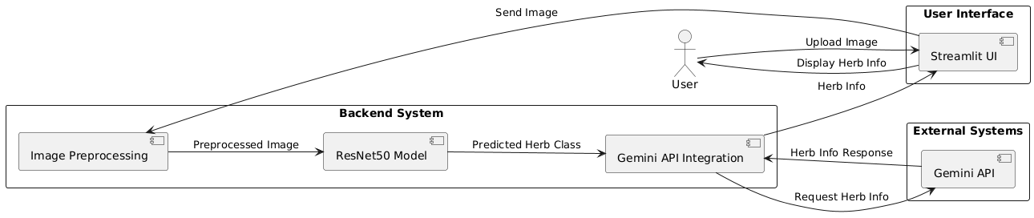

Flow
User Uploads Image → Image Preprocessed → ResNet50 Predicts Herb Name → Name Sent to LLM → LLM Returns Medicinal Info + Recipes → UI Displays Image + Info

Key Modules & Components

Frontend
Platform: Streamlit (Web UI)
Functions:
Upload leaf image
Display predicted herb name
Display medicinal uses and recipes
Backend
Model: ResNet50 (trained on custom 224x224 dataset)
Tasks:
Accept and preprocess image
Perform herb classification
Fetch response from Gemini LLM
Format and display the final result

Data Storage
No storage layer included in current scope
External Services
Gemini LLM API: To retrieve herb medicinal properties and recipes using the predicted herbname.

Technology Stack
Component | Technology Used
Language | Python
Frontend | Streamlit
Backend | PyTorch (ResNet50), Flask (optional for separation)
Model | Pre-trained ResNet50 (fine-tuned on leaf dataset)
LLM | Gemini Pro API (text response)
Tools | torchvision, PIL, requests

Data Flow
User Request Handling
User uploads a leaf image via Streamlit UI.
Image is resized and transformed to 224x224.
Image passed through the ResNet50 model.
Model outputs predicted herb class name.
Herb name sent to Gemini via API.
Gemini returns a description including properties and recipes.
Streamlit displays the uploaded image, herb name, and result.

Critical Data Paths
Image → Model → Prediction: Needs to be fast for good UX.
Prediction → LLM → Output: LLM latency is tolerable but should be cached in future iterations.

Scalability & Performance

Expected Load
Designed for small user base initially (single user/test use)
May scale in future for multiple concurrent users
Scaling Plan
Future option: Containerize with Docker
Use cloud (Streamlit Cloud or AWS) for broader access
Use async processing if LLM calls grow slow or heavy

Security & Compliance

Authentication
None in this version; Gemini API key stored securely in .env
Data Privacy
TLS secured if hosted online
No personal/user data collected or stored

Deployment Strategy

Infrastructure
Local deployment during development
Streamlit Cloud for demo deployment
Future option: Deploy on AWS/GCP with separate backend
CI/CD
Manual upload to Streamlit Cloud
GitHub for version control and collaboration

Risks & Assumptions
Risks
Model Generalization: Misclassification if image quality is poor or plant is not in dataset
LLM Cost/Latency: Groq may have API limits or delays
No Caching: Repeated requests for same herb will refetch from LLM
Assumptions
User provides clear leaf image (single leaf, well-lit)
Herb classes used in model are supported by LLM descriptions
Internet is available for API call to Gemini

Glossary – High-Level Design Document
Term | Definition
Streamlit | A Python framework used to build and deploy simple, interactive web applications, often for machine learning demos and dashboards.
ResNet50 | A 50-layer deep residual neural network used for image classification. In this project, it’s fine-tuned to classify medicinal herb leaves.
Gemini LLM | A large language model (LLM) developed by Google, used to generate descriptive text, such as medicinal properties and preparation methods for herbs.
Frontend | The part of the application users interact with. Here, it's the Streamlit interface used to upload images and view predictions.
Backend | The processing logic that handles image classification and calls the LLM API. It includes the ResNet50 model and functions written in Python.
PIL (Python Imaging Library) | A Python library for opening, manipulating, and saving image files.
torchvision | A PyTorch library that includes tools for image preprocessing, datasets, and pretrained models such as ResNet50.
requests | A Python module for sending HTTP requests, used here to communicate with the Gemini API.
LLM (Large Language Model) | A powerful AI model trained to understand and generate human-like text. In this project, it’s used to provide detailed herb information.
.env File | A secure configuration file used to store sensitive information like API keys, keeping them out of source code.
Docker | A containerization tool that packages applications and their dependencies for portable deployment. Mentioned for future scalability.
CI/CD (Continuous Integration/Continuous Deployment) | A practice in software engineering where code changes are automatically tested and deployed. In this project, updates are manually uploaded but GitHub is used for version control.
TLS (Transport Layer Security) | A protocol ensuring secure communication over the internet, important for protecting data during API usage or future hosting.
Model Generalization | The ability of a machine learning model to perform well on unseen data. Poor image quality or unknown herbs may reduce this.
LLM Latency | The delay between sending a request to the language model API and receiving the response. May impact user experience.
Caching | Storing previously retrieved data (e.g., herb information) to avoid repeating API calls, thus reducing latency and cost.
Image Preprocessing | The task of transforming images (resizing, normalization) so that they can be used by the neural network for classification.
Herb Classification | The process of predicting which medicinal plant class the uploaded leaf belongs to using the ResNet50 model.
System Block Diagram | A visual representation of how different system components interact, showing the flow from image upload to final output.
Data Flow | Describes the sequence of data processing steps, from user image input to LLM-generated medicinal information.
Critical Data Path | A portion of the system where speed is essential for a good user experience (e.g., image → model → result).
Scalability | The system’s capacity to grow and handle increased usage, with potential support for cloud deployment and multi-user access.
Risk: Misclassification | A potential error where the model incorrectly predicts a herb class due to poor image quality or unfamiliar input.
Assumption: Internet Availability | The system requires internet access to call the Gemini LLM API and fetch herb details.

Reviewed By:
Naveen Gunapaneni

